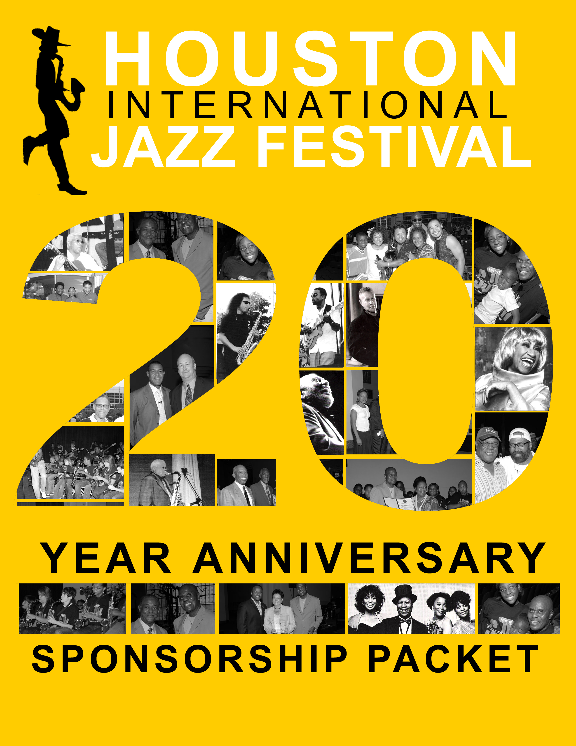

20th Annual

Expected Attendance

7,000+

Target Market

Music Lovers
Jazz Enthusiasts
Professionals

Overall Exposure

National

Ethnic

Caucasian 31%
Black 28%
Hispanic 24%
Asian 17%

Gender

Women 60%
Men 40%

Income

$25,000 - $75,000 81%

Houston
International
Jazz Festival

… Discovery Green
2010



Friday, August 6

Red Cat Jazz Cafe

Saturday & Sunday

August 7- 8

Discovery Green
4:00 p.m. to 10:00 p.m.

Sunday, August 8

Mayor’s Scholarship Jazz Brunch
Wortham Center/Grand Foyer
11 a.m.

Featuring
Summer Jazz Workshop All-Stars

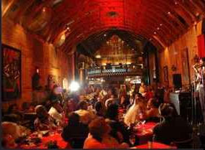
20th Annual
Houston
International
Jazz Festival
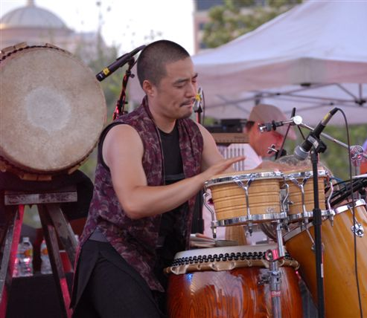

… Discovery Green
2010
(a product of Jazz Education, Inc. )

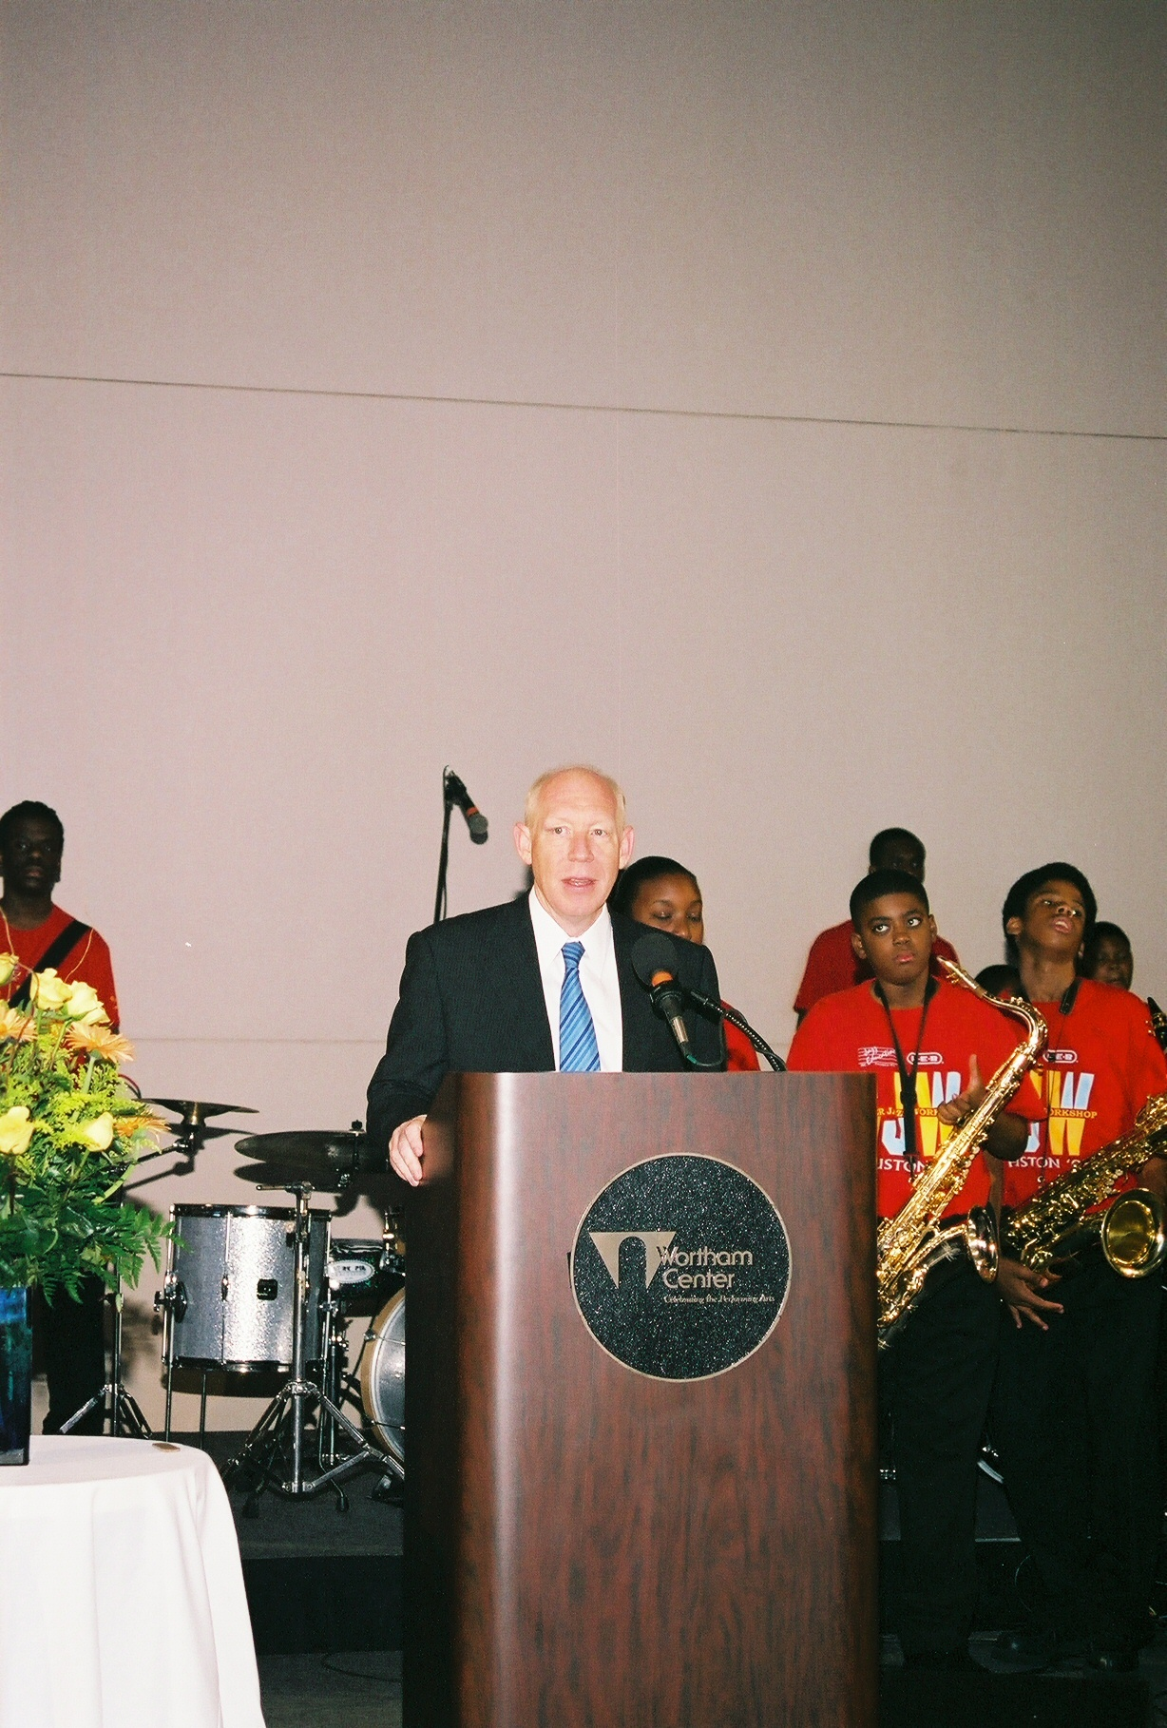
Mayor Bill White

20th Annual
Houston International Jazz Festival
… Discovery Green

Sponsorship for the 20th Annual Houston International Jazz Festival
Friday, August 1, represents the kick off of the celebration for August Jazz Month and the beginning festivities of the 20th Annual Houston International Jazz Festival. Our 2010 schedule of events include: The Mayor’s Scholarship Jazz Brunch, outdoor concerts at Discovery Green, and several pre-festival events. This year presents an excellent opportunity for you and the Houston International Jazz Festival to join forces in an effort to further link your Company with a diverse audience. All proceeds go to Jazz Education Inc. to support Music Education for underserved youth in the Southwest Region.

During the Festival you will witness some of the most inspirational Jazz Entertainment from around the World, bringing a diverse mix of styles to Houston, Texas. The timing is perfect for your organization to collaborate with the Festival as it further establishes its place among notable Events around the World. The attached Sponsorship packet presents several ways your company may increase its visibility and enhance its bottom line by partnering with the Houston International Jazz Festival.
Upon review, you’ll find a number of ways are available for you to effectively reach your target market and heighten your company’s visibility. Promotional opportunities range from title sponsorship to purchasing a table at the Mayor’s Scholarship Jazz Brunch, to placing items in the promotional gift bags for give-a-way. As you can see, the possibilities are limitless.
Please review the package, and if you have any questions, or if you are ready to become a sponsor, contact us at 713.839.7000 or jazzed@jazzeducatiion.org.
Become a sponsor before April 2010 and earn extra exposure through the Summer Jazz Workshop advertising.
Thank you for your consideration.
Very Truly Yours,

The Houston International Jazz Festival Coordinating Committee

20th Annual
Houston International Jazz Festival

A v a i l a b l e S p o n s o r s h i p s

Title Sponsorship $40,000

Presenting Sponsorship $25,000

Mayor’s Scholarship Jazz Brunch Sponsorship $15,000

Property Sponsorship $15,000

Program Booklet $ 7,500

Display Merchant Partnership $ 5,000

Kick-off Party $ 5,000

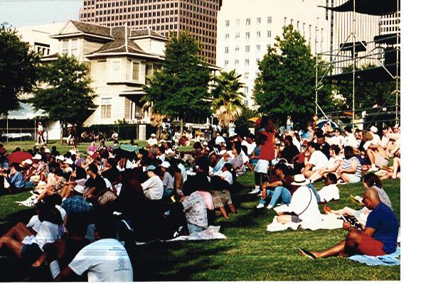


20th Annual
Houston International Jazz Festival
… Discovery Green

Title Sponsorship $40,000
“The Company Houston International Jazz Festival.”

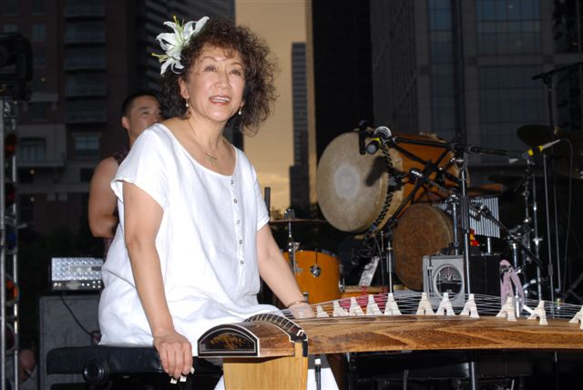
- Signage in Discovery Green and sponsorship recognition at all venues.
June Kuramoto - Hiroshima
- Announcer recognition during the event.
- 2 Tables (10 seats ea.) preferred seating at Mayor’s Scholarship Jazz Brunch.
- 30 VIP/100 General admission tickets to Discovery Green events.
- 10 VIP tickets to Kick-off Party at the Red Cat Jazz Café.
- Exclusive promotion and marketing rights within its product/service category of agreed upon trade names, logos and products of The Company for the Houston International Jazz Festival.
- Product identification on all press releases sent to all news wire services, travel and music publications.
- Name and or Logo on all printed material and Billboards.
- Name and or logo on all paid television spots.
- Name to be included in all paid radio spots.
- Name and or logo on all Print ads in the newspapers, magazines, etc.
- Right to use HIJF name, logo, and sponsorship mention in advertising during 2010.
- All media advertising - radio, TV, print - must be signed off on by HIJF before going to print.

20th Annual
Houston International Jazz Festival

… Discovery Green

Presenting Sponsorship $25,000
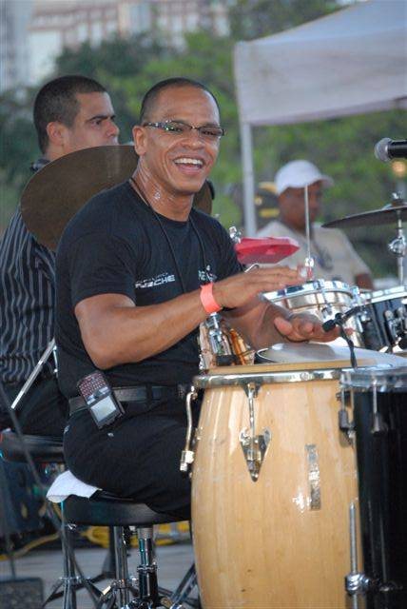
- The event to be styled The Houston International Jazz Festival presented by You Company.
- Banner/Signage as Presenting Sponsor on stage.
- Announcer recognition during the event.
- Name and or logo on all paid television spots.
- Name to be included in all paid radio spots.
- Name and or logo on all Print ads in the newspapers, magazines, etc.
- Exclusive promotion and marketing rights within its product/service category of agreed upon trade names, logos and products of The Company for the Houston International Jazz Festival.
- Product identification on all press releases sent to all news wire services, travel and music publications.
- Name and or Logo on all printed materials and Billboards.
- 30 VIP / 80 General admission tickets to Discovery Green and 10 VIP tickets to the Kick-off Party at the Red Cat Jazz Café.
- 2 Tables (20 seats) Preferred seating at Mayor’s Scholarship Jazz Brunch.
- Promotional display and or merchandising opportunities.
- Right to use HIJF name, logo, and sponsorship mention in advertising during 2010.
- All media advertising - radio, TV, print - must be signed off on by HIJF before going to print.

20th Annual
Houston International Jazz Festival

… Discovery Green

Property Sponsorship $ 15,000

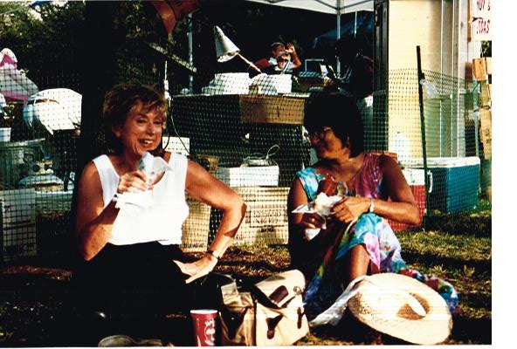
- The area to be styled “The Company Jazz Lounge”.
- Banner/Signage in Discovery Green.
- Announcer recognition during the event.
- 20 VIP/30 General admission Tickets to Discovery Green.
- 1Table (10 seats) preferred seating at Mayor’s Scholarship Jazz Brunch.
- Promotional display and or merchandising opportunities.
- Exclusive promotion and marketing rights within its product/service category of agreed upon trade names, logos and products of The Company for the Houston International Jazz Festival.
- Product identification on all press releases sent to all news wire services, travel and music publications.
- Name and or Logo on all Posters, Banners, Flyers, Invitations and Billboards.
- Name and or logo on all paid television spots.
- Name to be included in all paid radio spots.
- Name and or logo on all Print ads in the newspapers, magazines, etc.
- Right to use HIJF name, logo, and sponsorship mention in advertising during 2010.
- All media advertising - radio, TV, print - must be signed off on by HIJF before going to print.

20th Annual
Houston International Jazz Festival

… Wortham Center

“Kroger’s Mayor’s Scholarship Jazz Brunch” $15,000

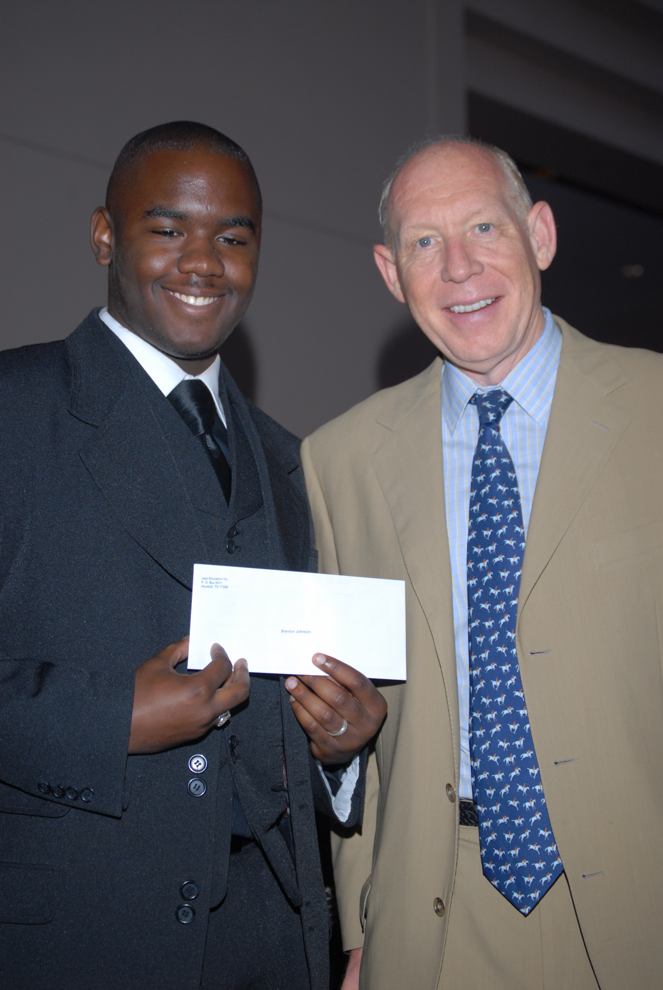
- Announcer recognition during the event.

- Signage as Mayor’s Scholarship Jazz Brunch sponsor.

- 2 Tables (20 seats) preferred seating to the Mayor’s Scholarship Jazz Brunch.

- Promotional display and or merchandising opportunities.
Brenton Johnson receives a $1,500 “SJW Scholarship Award” from Mayor Bill White at the 2008 Mayor’s Scholarship Jazz Brunch and will attend New School for Jazz and Contemporary Music in New York.

- Name/Logo on all printed
materials press releases, billboards,
paid TV & radio spots.

- 20 VIP/50 General admission tickets to Discovery Green and 10 VIP tickets to the Kick-off Party at the Red Cat Jazz Café.

- Exclusive promotion and marketing rights within its product/service category of agreed upon trade names, logos and products of The Company for the Houston International Jazz Festival.

- Right to use HIJF name, logo, and sponsorship mention in advertising during 2010.

- All media advertising - radio, TV, print - must be signed off on by HIJF before going to print.

20th Annual
Houston International Jazz Festival

… Discovery Green

Official Program Booklet Sponsorship $ 7,500

The HIJF will provide:

- Product name and or logo carried on all advertising and promotional material.

- Category Exclusivity - Official HIJF Program Booklet Sponsor.

- Back Page Cover.

- 1 Table (10 seats) Preferred seating at Mayor’s Scholarship Jazz Brunch.

- 8 VIP/20 General admission Tickets to Discovery Green and 4 VIP tickets to the Kick-off Party at the Red Cat Jazz Cafe.

- First right of refusal to be the Official Program Booklet for the 2011 HIJF. This first right of refusal will be valid for 15 days following HIJF’s proposal for the 2011 HIJF. It is understood that the terms of the proposal for HIJF 2011 may vary from the terms of the sponsorship proposal for HIJF 2010.

20th Annual
Houston International Jazz Festival

… Discovery Green

Display Merchant Partnership $ 5,000

The HIJF will provide:

- 1 Table (10 seats) Preferred seating at Mayor’s Scholarship Jazz Brunch.

- Product name and or logo carried on all advertising - broadcast media, print media and promotional material.

- Product display/sales at Discovery Green.

- 8 VIP/10 general admission tickets to Discovery Green and 4 VIP tickets to the Kick-off Party at the Red Cat Jazz Cafe.

- Category exclusivity.

- First right of refusal for the 2011 HIJF. This first right of refusal will be valid for 15 days following HIJF’s proposal for the 2011 HIJF. It is understood that the terms of the proposal for HIJF 2011 may vary from the terms of the sponsorship proposal for HIJF 2010.

20th Annual
Houston International Jazz Festival

… Discovery Green

Kick-off Party $ 5,000

The HIJF will provide:

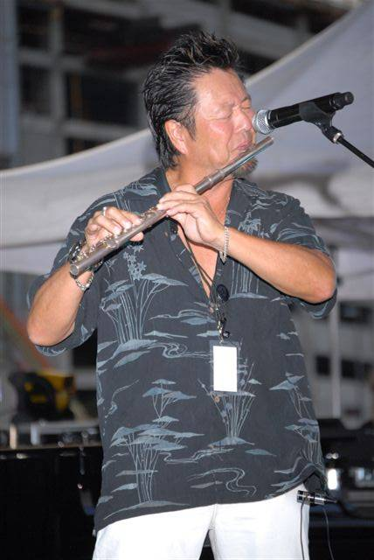
- 1 Table (10 seats) Preferred seating at Mayor’s Scholarship Jazz Brunch.

- Product name and or logo carried on printed advertising and promotional material.

- Product display/sale at Red Cat Jazz Café.

- 20 VIP tickets to Kick-off Party at Red Cat Jazz Café and 4 VIP/10 general admission Tickets for Discovery Green.

- First right of refusal for the 2011 HIJF.
This first right of refusal will be valid for 15 days following HIJF’s proposal for the 2011 HIJF. It is understood that the terms of the proposal for HIJF 2011 may vary from the terms of the sponsorship proposal for HIJF 2010.

20th Annual

Houston International Jazz Festival

… Discovery Green

Media Sponsorship

- Name and or Logo on all Posters/Banners/Flyers/Invitations and Billboards.
- Signage at Discovery Green and sponsorship recognition at all venues.
- Announcer recognition during the event.
- Right to use HIJF name, logo, and sponsorship mention in advertising during 2010.
- 1 Table (10 seats) preferred seating at Mayor’s Scholarship Jazz Brunch.
- 20 tickets to Discovery Green 8/7 and 8/8, 6 VIP tickets to Red Cat Jazz Café Kick-off Party.
- Exclusive promotion and marketing rights within its product/service category of agreed upon trade names, logos and products of The Company for the Houston International Jazz Festival.
- Product identification on all press releases sent to all news wire services, travel and music publications.
- Name and or logo on all paid television spots.

The Houston International Jazz Festival

In the winter of 1988, Bubbha Thomas, executive director of Jazz Education Inc. approached the late U.S. Congressman Mickey Leland to seek support for a Houston International Jazz Festival. Congressman Leland enthusiastically responded, “Bubbha you get the talent and I’ll get the sponsorships.” Leland was not here to witness the first Houston International Jazz Festival. He died on August 6, 1989, while on a humanitarian mission to Ethiopia.

In 1991, in memory of Congressman Leland, the first Houston International Jazz Festival was held outdoors on the “Super Block” in front of the George R. Brown Convention Center. In 1994, Bubbha approached Councilman Judson Robinson III, son of Houston’s first Black City Councilman, Judson Robinson Jr., and shared the story of the vision of the Houston International Jazz Festival and the history of Jazz Education Inc. The rest is History.

Since its inception, in association with “August Jazz Month Houston”, the Houston International Jazz Festival has placed Houston in the spotlight as the site of the nation’s only Jazz Festival focusing on international Jazz musicians. The mission of the Festival is to provide a unique cultural program that exposes Houstonians to musicians from outside the United States of America. All proceeds from the festival go toward funding Jazz Education Inc.’s educational programs, “Jazz & Poetry Series” and “Summer Jazz Workshop.” The Jazz and Poetry Series serves more than 30,000 elementary school children, and through two locations, the Summer Jazz Workshop trains over 100 teenage musicians yearly.

Other goals of the Festival are to provide scholarships for underserved children attending the Summer Jazz Workshop and establish an endowment for the long term growth of Jazz Education Inc.

From an artistic standpoint, the Festival gives Houstonians and Texans an opportunity to see the influence of this great American art form in action, as demonstrated by foreign musicians. For our young people, this is very important.

